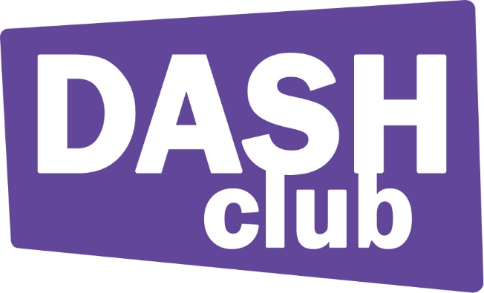
Fundraising Volunteer

Organisation: The Dash Club
Status: Part-time voluntary
Location: Possilpark, Glasgow/various
Website: www.dashclubglasgow.org.uk

We are looking for dedicated volunteers who are passionate about experiences of secondary aged young people with special needs. Volunteers will have the opportunity to develop skills based around teamwork, leadership, finance, communication and interpersonal skills. Successful appointments will be based on the volunteer’s desire to enhance their skills and their dedication to improving the experiences of young disabled people. Successful applicants will be required to go through PVG checks.
We are interested in applications from people from various and diverse backgrounds of the following groups: Long term unemployed, single parents, young and mature people, women, disabled, black or ethnic minority and/or LGBT+ people.

About the Dash Club
The Dash Club delivers after school and holiday programs for young people with disabilities who are aged 11 to 14 years old. Originally created in 1999 in response to an obvious gap in informal education for disabled children in Glasgow. All our clients have a learning disability combined with a physical and/or visual impairment. Additionally, many come from disadvantaged backgrounds such as having more than one disabled child in family, coming from single parent background and/or living in living in areas of multiple deprivation. We offer those young people the opportunity to socialise in afterschool activities where they get to improve their mental and physical health through sport, art, games, social outings, trips and residential events all in safe environments.

- Work Location
Volunteers will mostly work within the Glasgow region. However, there may be occasions in which volunteers may have to travel out with. Travel costs and other expenses for volunteer work will be reimbursed.
- Purpose of the Position
Successful applicants will work with The Dash Club to fundraise money to help support the charity’s services whilst learning crucial skills. Through public engagement volunteers will help assist The Dash Club with increasing the understanding of disability issues amongst the Glasgow region and beyond.
- Responsibilities and Duties
- Volunteers will be expected to undergo training to training to help skills in public speaking, engagement, campaigning, leadership, teamwork and fundraising.
- Will be tasked to boost The Dash Clubs social media presence on platforms such as Twitter, Facebook, Instagram, Snapchat etc.
- Will be expected to raise the awareness of the issues that young people are faced with on a day to day basis to the public.
- Volunteers will assist in the recording of their own development throughout the programme.
- Volunteers will form groups and be allocated certain roles within each team and be encouraged to inspire and motivate others. Volunteers will also have the opportunity to rotate roles to gain leadership and others various skills.
- Qualifications
No qualifications are required for voluntary positions. However, successful applicants will be based on dependability, a polite manner and will need to demonstrate a passion for improving conditions for disabled people.
- Commitment Expected
The programme will last roughly for six months in which volunteers are expected to do a minimum of 4 hours per week.
- Support and Benefits
As previously stated volunteers will be offered training. The Volunteer Coordinator will also be there to provide assistance to volunteers and ask any questions. Volunteers will also be credited based on the number of hours they do and have the opportunity to earn credits and qualifications from the role
Last updated: 20/10/16

